**UBUNTU BY CANONICAL**

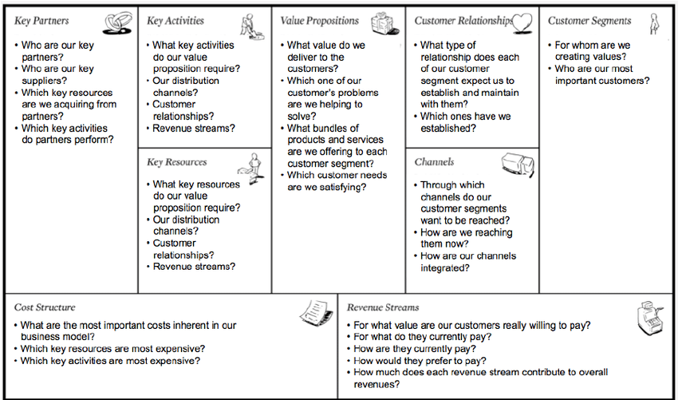

**Canonical’s mission is to help governments and businesses the world over with migrations, management, and support for their Ubuntu deployments. Ubuntu is an OS developed in Linux.**

**Key Partners:**

Canonical partners with other firms to help them sell its offerings or enhance usage of the offerings for the firms’ customers. The types of partners are for example (there are alot):

* **Public Cloud** -- As part of its public cloud providers program, Canonical provides optimized Ubuntu images, management, and commercial support to the biggest clouds in the world
* **OpenStack** – The company uses an integration lab called OpenStack Interoperability Lab to test its cloud partners’ products in various Ubuntu OpenStack configurations
* **Charm** -- The Charm Partner Program is described as the fastest route for ISVs and solution providers to take advantage of all that the Ubuntu cloud and server ecosystem has to offer
* **Channel** – The company enables channel partners to provide management and support for Ubuntu, expanding their service portfolios

**Key Activities:**

Entails designing, developing, and delivering its services to its customers

**Value Propositions:**

Canonical offers five primary value propositions: accessibility, convenience, pricing, performance, and brand/status.

The company creates accessibility by providing a wide variety of options. It makes Ubuntu available worldwide through retail channels, most major public clouds, and its network of partners. In addition, the platform runs on several devices, including computers, smartphones, tablets, and TVs.

The company offers convenience by making life simpler for customers. It provides employees to assist with all aspects of Ubuntu management, from design and development to training and certification to support.

The company offers a pricing value proposition. Customers can download, use, and share Ubuntu for free. Moreover, they can try its complementary tool Landscape free for 30 days.

The company demonstrates strong performance through tangible results. It helped the Penn Manor school district set up a network of 1,700 Ubuntu laptops. In one year, savings on license fees for the computers (as compared to an alternative laptop) amounted to $200 per laptop, a total of $345,000.

The company has established a strong brand due to its success. It touts Ubuntu as the leading operating system for cloud operations – used by most public cloud workloads, new smart gateways, advanced robots, self-driving cars, and switches.

**Customer Relationship:**

Canonical’s customer relationship is primarily of a personal assistance nature. The company assists customers with its flagship service, Ubuntu Advantage, through which it does the following:

* **Plan and Install** – The company builds and installs a solution on trial systems, monitors it, then provides deployment recommendations
* **Deploy** – The company configures and then deploys the system
* **Train** – The company trains clients on how to manage their deployments
* **Manage** – The company works with client teams to monitor and optimize their deployments on an ongoing basis, offering 24/7 phone, e-mail, and portal support

There is also a community element in the form of a peer forum where clients can interact.

**Customer Segments:**

The company mainly targets its offerings at businesses and governments.

**Key Resources:**

Canonical’s main resources are its human resources, who include the more than 500 designers, developers, and project managers that help design, develop, and deliver its services. Many are Ubuntu desktop, server, and cloud experts.

**Channels:**

Canonical’s main channels are retail channels, major public clouds, and its network of partners. The company promotes its offerings through its website, social media pages, and conferences.

**Cost Structure:**

Canonical has a personal assistance structure, providing a premium proposition through significant personal service and frequent service enhancements. Its biggest cost driver is likely sales/marketing, a variable expense. Other major drivers are in the areas of customer support and cost of services.

**Revenue Streams:**

Canonical has one revenue stream: revenues it generates from the sale of technical support and other Ubuntu-related services to customers. Sales typically occur through the formation of contracts.

**Consider how the OSS project and its community fits into the company’s business model. For example, which of the nine BMC components do they relate to?**

All of them? Ubuntu is a OSS project that is used by companies and private users. Every BMC component is about Ubuntu and it’s positive aspects around OSS, development, user experience and support.